DODGES TOO GOOD FOR THE PORT
The Cygnet Seniors and Reserves last week fronted up for their longest road trip of the season, down to Shark Park, Dodges Ferry. In recent years it has always been a challenge for visiting teams as Dodges play their home ground very well, particularly when the wind is up. It was a chilly start to the day but fortunately the rain held off and the sun shone for most of the afternoon.
Reserves
The Port Reserves were minus injured captain Darcy Millhouse and missing one interchange player for their game against the Sharks. Desperate to get a side together, coach, Matthew Whitehouse pulled on the Port jumper once more with Southern Storm Colt’s Jacob Burnett and Blake Sculthorpe also helping out.
The return of Chris Coventry and Sam Dean back from their overseas travel was also a welcome addition to the side.
With so many changes to the side, one could be forgiven for not having high expectations for a competitive match. To the credit of every player who pulled on the Port jumper, this could not have been further from the truth. Coach Whitehouse set the standard for his team with several committed actions, Matthew Coulson continued his superb run of form and with the support of Sam Dean was influential at the stoppages. Blake Sculthorpe and Tom Slevin repelled many attacks from Dodges Ferry. The two Christopher’s - Stockfeld and Coventry, were also having an influence around the ground.
At the main break, it was only 13 points the difference in a very competitive match. Unfortunately, the third quarter was zero goals to the Port and four against which did not reflect the evenness of the two sides but more of Dodges Ferry’s ability to better capitalize on their opportunities.
Slevin, Coulson, Dean, Sculthorpe and Stockfeld continued their good performances in the second half. Solid performances were also put in by Brandon Lane and Julian Direen across the entire match and final quarter goals to Shane Clark (his second for the game) and Brandon Lane were just reward for their efforts. Dwain Warn and Matt Coulson were the other goal scorers.
The final margin was 54 points to the Sharks, but good fighting spirit and commitment was shown from an undermanned Port bunch.
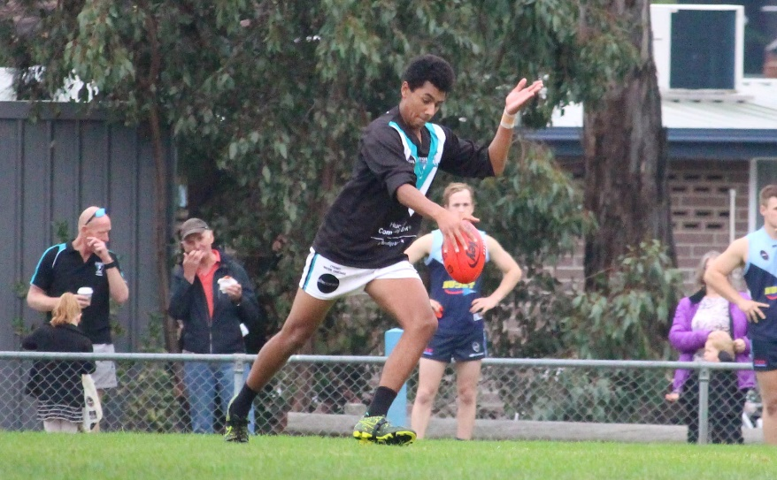
Seniors
With a strong breeze blowing to the end of the Sharks in the first quarter, the Port jumped out of the blocks well, dominating the inside 50’s early with goals to 50th gamer Elijah Reardon, Patty Verrell and Ben Halton. The latter part of the quarter belonged to the Sharks as they rallied hard to take the honours with the inside 50’s for the quarter and to even up the centre clearances.
Young gun Jack Brereton battled well with a quality Sharks ruckman giving the Port midfield plenty of opportunities and a late goal by James Zeitzen and the Port lead by four points at the first change.
The second quarter saw the Port struggle to capitalise on the strong breeze as the Sharks defence held strong. While the centre clearances and the inside 50’s were very even in this quarter the Sharks dominated the play, kicking four goals to the Port’s two goals (Ben Halton and Joe Direen) and Dodges now had their nose in front by 7 points.
At half time coach, Ben Cato, pleaded with the Port to maintain possession and be smart before bombing away with the ball into our forward line. All the key statistics from the third quarter reflected the scoreboard – being quite even. Dodges kicked a couple of early goals to extend their lead but to their credit the Port fought back with goals to Joe Direen, Jake Dance and Liam O’Neill and the margin remained 7 points in the Shark’s favour at three quarter time.
The final quarter saw the Sharks win the centre clearances and the inside 50’s and on the scoreboard. The Sharks scored three goals to the top end while the Port could manage only two goals (Reardon and Toby Cowen) and the home team ran out winners by 19 points.
Captain Rhys Jennings led by example as usual, being at the bottom of every pack and pleaded for more from his players. Mitch Direen showed there was plenty of pace in the old legs by providing good of run off the backline and many forward thrusts. Matt Turnbull provided plenty of spark in his first game back from injury, Cameron Wilcox, Jackson Gordon and Campbell Gane once again were solid in defence and Liam O’Neill contested well all day.
Goal kickers for the Port were Reardon (2), Halton (2), Joe Direen (2), with singles to Cowen, Verrell, Zeitzen, Dance and Liam O’Neill.
Overall, it was a disappointing result for the Port who really seemed to struggle with the wind all game. Uncontested errors and turnovers ended up being the difference with the Port displaying some very ordinary disposal and decision making at times.
The Port loss and wins in the round to Dodges and Hobart has really tightened up the race for fourth and fifth spots on the ladder, with only one win and percentage separating four teams (Cygnet, Hobart, Dodges Ferry and New Norfolk).
No Men’s games this week
With the SFL Representative game on this weekend, there will be no men’s (Seniors, Reserves or Colts) games played, however the Port Women will play the Hobart Tigers at New Town Oval on Sunday at 3pm.
The following week (Saturday 21st July) will be another bye round for the Port Senior and Reserve teams while the Southern Storm Colts will play Lindisfarne at Anzac Park. The Port Women will play University at University Oval on Sunday 22nd July.

