PORT HANG ON FOR CLOSE WIN OVER HOBART TIGERS
Last Saturday the Cygnet Football Club were at home to Hobart in what was a must-win game for both teams with fourth place on the ladder up for grabs. The Reserves were looking for their third win of the season while the Storm Colts were keen to secure second place against again an improving Hobart side.
On Sunday the Port Women also played at home against the undefeated and top SFLW team, the South East Suns.
Colts
Hobart Colts really took it up to the more fancied Southern Storm early in their contest, with the slippery conditions making clean ball handling difficult for both teams. The Storm welcomed back James Zeitzen and Jordan Lane after their stints in the Port Seniors, but Hobart took the early lead with a two goals to one goal first quarter. With the Storm struggling to get their running game going, the Tigers continued their good play in the second term and extended their lead slightly to nine points at half time.
The Storm defence worked hard to restrict their Tiger opponents to two behinds for the third quarter, but were themselves inaccurate with only one goal from six scoring attempts and scores were locked at 34 points apiece with a quarter to play. The Storm’s fitness became evident in the final quarter as they finally got their running team game going and were able to put on four goals while keeping Hobart to two behinds and the final margin was 23 points in the Storm’s favour.
Good contributors for the Storm were Ethan Lovell, Mitch Innis who ran hard all day and bobbed up with two last quarter goals, Luke Ashlin and Lukas Ford who both won many possessions, captain Josh Coad who again led by example and Jordan Lane. Jake Munnings, playing his 50th Club game and James Zeitzen each kicked two goals, with single goals scored by Connor Soward and Lukas Ford.
Reserves
The Reserves welcomed back former senior player Darris Fahey, returning to help his club out. In his first game for the Port since 2009, Darris played in his normal flamboyant style but failed to find the big sticks.
Hobart got off to a quick start and were soon regularly hitting the scoreboard, while the Port were having difficulty penetrating the Tiger’s defence, and only able to score a solitary behind for the quarter to be down by 28 points. It was more of the same in the second quarter with Hobart kicking three goals to the Port’s one goal and Hobart had extended their lead to 44 points at half time.
Unfortunately for the Port, Hobart weren’t easing off and really kicked away in the second half with six goals in the third quarter and five more goals in the final quarter. To their credit, the Port never stopped trying and two last quarter goals were reward for their efforts. The game was not nearly as one sided as the final margin of 96 points might suggest, but Hobart’s superior running ability and fitness increased their ability to score.
For the Port, Kane Nielsen again showed his class and experience in the ruck and general play, giving good service to his onballers and he also snuck forward to kick a goal. Mark ‘Chopper’ Bradley continued his excellent form, reading the play well and with accurate disposal. Matthew Coulson was back in form bashing and crashing packs as did Sean Burgess in a solid game on the wing. Brandon Lane showed his potential and 50th gamer Captain, Dallas Millhouse played his consistent solid and hardworking game.
Another 50th gamer, Ollie Burke kicked the other two goals in what was a disappointing result for the Port.
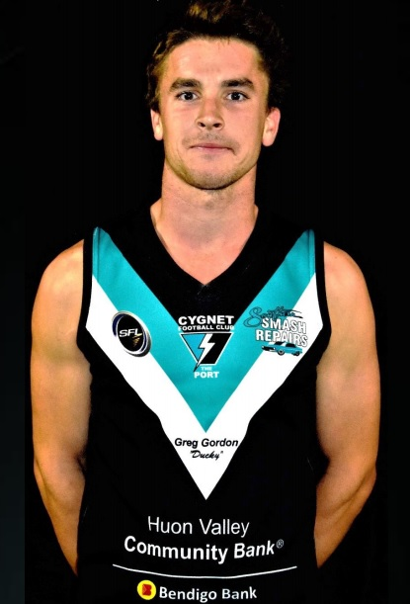
Seniors
The Port Seniors were looking to get back on the winner’s list and to commemorate Rhys Jennings’ 200th senior game. As the Club’s Senior Co-Captain, Rhys leads by example, always putting his head over the ball and pound for pound he would have to be one of the most fearless small men going around, always in and under the packs and usually the last to get up with the ball. Jackson Gordon and Jake Dance were also lining up for their 50th Club games, in their third seasons with the Southern Storm and Port. Congratulations Rhys, Jackson and Jake on reaching these milestones.
With several teams in the running for the final two spots in the top five, the Senior contest between Cygnet and Hobart was effectively an eight-point game, with the winner moving into fourth place and moving one game clear of their opponent.
The Port got off to a good start and looked dangerous early in the game with goals. Although the centre clearances were even by quarter’s end, Hobart were dominating the inside 50’s and piled on six goals to the Port’s four goals (Elijah Reardon 2, Ben Halton and Toby Cowen) to give the visitors a handy 15 point lead at quarter time. The second quarter saw the battle of the midfields continue with both teams again sharing the centre clearances. However the Port were now on top of the inside 50’s and giving their forwards plenty of opportunities. The Port scored four goals (Halton, Rhys Jennings, Joe Direen and Jason Shaw) to Hobart’s two and Hobart’s lead was only five points at half time.
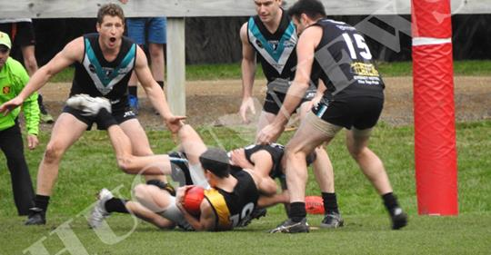
It was a similar scoring pattern in the third term as the Port kicked a further four goals (Direen, Cowen, Jake Dance and Andrew Palmer) to Hobart’s two to take the lead by 8 points with another nail-biting finish on the cards. The Port were winning the centre breaks and had the majority of the play in the final quarter but were wasteful in front of goal, kicking one goal eight behinds for the quarter, including several posters! Despite the margin getting down to three points with only a few minutes remaining, the Port managed to hold on for an important eight point victory.
Campbell Gane played a top game and was rock solid in defence and Toby Cowen was his usual creative self, providing plenty of outside run off the half forward line and was also very handy in front of goal kicking 2 majors. Mitchell Direen provided plenty of run out of the backline, creating many forward thrusts, while Ben Halton (3 goals) provided plenty of opportunities up forward with strong hands and by bringing those around him into the game. In his first senior game for the season, Jeremy O’Neill did a lot of the hard work in and under the packs, providing many second and third efforts that helped lift the team. Pat Verrell acquitted himself very well in shutting down one of the Tigers best players.
Elijah Reardon and Joe Direen both kicked two goals, with single goals to Rhys Jennings, Jake Dance, Jason Shaw and Andrew Palmer.
Port Women
On a sunny Sunday with a light breeze, the Port Women’s game against the South East Suns kicked off. The Suns were quick to score a couple of goals while the Port were finding scoring difficult against the tough Sun’s defence. The first quarter score was the Suns 3 goals to the Port zero.
The second quarter saw the Port pick up their defensive line again and were able to stop the Suns from scoring while at the other end the Port worked hard to get the ball down into their forward line for Grace Lovell to score a behind, and the only score for the quarter. At half time the score was 18 – 1 in the Suns’ favour.
In the third quarter the onballers and backline continued to work extremely hard against the Suns with the game being a tough and very physical affair. All the Port players stepped up and with some hard hits bounced back and kept digging deep to restrict the Suns to one goal and a 24 – 1 scoreline at the final break.
The last quarter saw the Port’s sheer persistence and guts really take it up to the Suns and put them off their game, holding them to four behinds only. The final score was Suns 4-4-28 to the Port’s 0-1-1, and a fantastic effort by the Port ladies to restrict the Suns to one solitary goal after quarter time.
The Port welcomed Jaice Jackson and Amelia Watson into the squad, and both showed their strong determination by not giving up after being thrown into the deep end playing their first game against the top team.
In an excellent team performance, better players were Hayley Flakemore, Samantha Kluga, Ash Munnings, Taylah Dillon, Holly Upston and Tia Duggan.
This week’s games
This Saturday the Port men travel to Dodges Ferry in what is another critical “must win” game for the Seniors. The Southern Storm Colts have a bye as Dodges aren’t fielding a Colts team this season, while the Port Women also have the bye and a well-deserved week’s rest.
Last Man Standing
The Club wishes to thank everyone involved in organising last Saturday night’s ‘Last Man Standing’ social function, a great fun night was had by all. Congratulations to Gaye Hansson who won the $1000 prize in the card competition.

