PORT CLUB NOTES – 12 August 2017
IMPORTANT GAMES FOR THE PORT THIS WEEKEND
This Saturday the Port and Southern Storm Men’s teams travel to Pembroke Park for the last roster games of the season.
A win for the Port Seniors over Sorell will move them into fourth spot on the ladder, and importantly a home final the following week. The Storm need to win to remain in 3rd spot on the ladder, and retain their double chance. Unfortunately the Reserves will miss out on the final’s action.
On Sunday afternoon, the Port Women will also play their final roster match against the Lindisfarne Blues at the Kingborough Twin Ovals, with the first bounce at 1.40pm.
Last week’s game
The Port Women were the only Port team to play last weekend, when they travelled to Abbotsfield Park on a cold and windy Friday night for a bottom of the table clash against Claremont Women. Port went into the game with a 2-0 record against Claremont and were favorites to win, having come away with 86 and 35 point wins in their previous two contests.
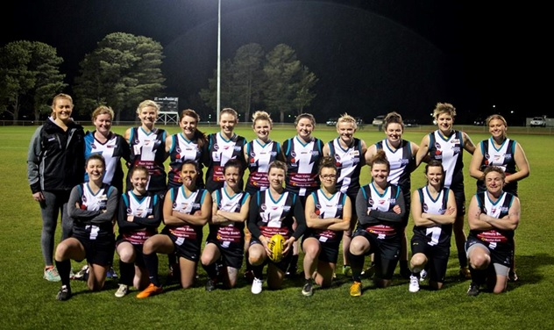
For most of the Port players, the conditions were the worst they had experienced in their short football careers, as they were challenged by strong winds, a wet ball and a very slippery surface. Port won the coin toss and had the early wind advantage. April Pottinger fought hard in the ruck and won most contests with Maddy Hall playing her best game of the season chasing hard after the ball. However the Port failed to use the wind advantage and managed to only score one behind, leading by that narrow margin at quarter time.
Claremont had the wind advantage heading into the second quarter and capitalised. Keren Scotney stepped up and chased the ball relentlessly in the backline and attempted to protect the Port’s backline as much as possible with the assistance from Sherilyn Atkins-Collins, but despite their desperate efforts, Claremont scored 2 majors to lead by 13 points at half-time.
The Port decided to change a few things heading into the third quarter and placed their top three players of the game, Brittney Woolley alongside sisters, Teletha Bird and Caitlyn Phillips in the midfield. They each attacked the ball ruthlessly and were able to keep the majority of the play in the Port’s attacking half for the quarter. Kara Geeves played a strong game inside the forward 50 kicking the Port’s first goal and trying to keep her team in the game. Unfortunately Claremont responded with another major late in the quarter, and lead by 11 points at the final break.
The fourth quarter was a hard fought contest with all players giving everything they had. After a tough battle Port were able to kick another goal, reducing the margin to one point, before Claremont kicked another major score with only three minutes to go, to defeat the Port by 7 points.
A great effort by the Port Women in very difficult conditions. With one game to go they will finish in 4th position on the ladder, which should secure them a semi-final berth. Well done girls.
Port Best & Fairest Count
The Club’s Best & Fairest counts will take place next Saturday (26th August) at the Clubrooms, commencing at 7pm. There will be a count for the Colts, Reserves, Port Women and Seniors (including the Synnott Brothers Award).
Thank you to Sponsors
As the 2017 season moves into the final series, the Cygnet Community Bank Football Club would like to acknowledge the wonderful support of our sponsors, weekly award and trophy donors and members. It is only through their generous support and financial contribution that the Port is able to remain viable year on year.

GO THE PORT!!!!

