PORT NEWS - SOUTHERN STORM TOPPLES TOP TEAM
With the PORT Senior and Reserve teams having the bye round, it was up to the Southern Storm Colts and PORT Women to satisfy the local spectator’s footy fix last weekend.
Southern Storm
The Southern Storm Colts travelled to Boyer last Saturday to take on the ladder leaders, New Norfolk with a full strength side for the first time this season. The Storm dominated play in the first quarter winning the centre clearances but were unable to convert as they would have liked, letting New Norfolk kick two very late goals, but the Storm were six points up at quarter time.
The second-quarter played much the same with the Storm controlling play but unable to convert. At the half-time break, Coach Matty Brereton asked for more run and smarter ball use and the Storm lads took this on board, kicking five goals straight to one in the third quarter to extend their lead to 32 points.
The Storm dominated play for the first 5 to 10 minutes of the final quarter but again were unable to put it on the scoreboard, allowing their New Norfolk opponents to get two late goals. The Storm dominated play all day with the backline combining together well to hold New Norfolk out whilst the midfield ran hard and linked up well, switching the play on numerous occasions . The forward’s tackling pressure was pleasing too, often locking the ball into the forward 50 metre area.
Overall a great team effort from the Storm, with good contributions from Jackson Gordon, Marcus Coulson, Nathan Duggan, Liam O’Neill, Jack Brereton and Will Donato. Joe Direen, in his first Colt’s game for the season booted three goals along with Marcus Coulson, whilst Liam O’Neill, Elijah Reardon, Jackson Gordon and Jake Dance scored a goal each.

PORT Women
In Round Six of the Women's Comp, Port hosted the Hobart Demons at the Kingborough Twin Ovals last Sunday. After a come from behind win against the Demons in the first round and with some key players out, the Port were still hoping for another closely contested match.
In the first term, the Demons came out determined and were able to create enough scoring opportunities to open up a 23 point lead at quarter time, despite the efforts of Samarni Thomas through the midfield. The second quarter script read similar to the first, with the Port again unable to hit the scoreboard, despite the hard running of Georgia Baldwin and Kara Geeves and forced to play both an attacking and defensive roll. At the main break the Demons held a substantial 56 point lead.
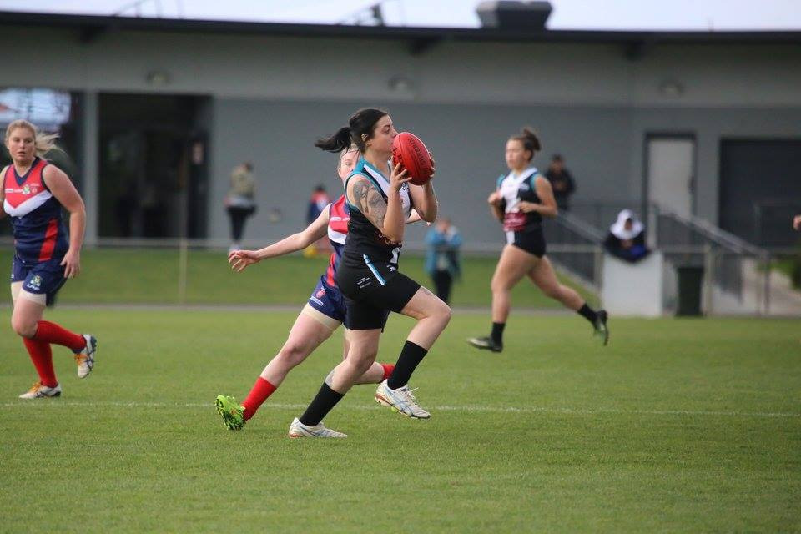
With rain starting to fall at the main break, Marlin Letiko was able to take control of the ruck and with Emma Dayton pushing hard, the Port limited the Demon’s ability to clear the ball from the stoppages. April Pottinger was again an effective tagger and with Geeves converting Port’s first major, it was a more tightly contested quarter between the two teams. In the final quarter, although limited again on the scoreboard and with Keren Scotney working overtime on the backline, the Port were able to hold the Demons to just one goal for the quarter. Heidi Pettit pushed hard throughout all day and the Port women never quit, despite the score line.
Emma Dayton breaks away from her Demons opponent
Despite the final margin of 72 points in the Demon’s favour, it was a fine effort from the Port, who were limited in player numbers, having no rotations left on the bench at the final siren.

No SFL games this week
There will be no SFL Men’s or Women’s games this long weekend due to the Tasmanian Representative game. The PORT’s next games will be the following Saturday (17th June) against Sorell at Channel’s Snug Park.
The PORT welcomes aboard our new Corporate Sponsor, Tom Moore & Son who will sponsor the game at Channel. It should be a great day with the Port Women playing the South East Suns between the Reserve and Senior games. So get along for what promises to be four great games of footy.

