PORT NEWS
MIXED RESULTS FOR THE PORT AND FOOTY BACK AT KERMANDIE
PORT Women
It was Friday night footy at its best last Friday night as the evening Bridgewater Jerry closed in on a chilly Anzac Park, Lindisfarne, but the temperature was heating up on the field.
Expecting a tough contest, the ladies went out fighting early. Kara Geeves and Caitlyn Phillips continued to show they are a force for the opposition in attack, both scoring goals off the other’s unselfish one-two play. The Two-Blues went into the quarter time break with a slight advantage over the Port.

From then on, the PORT were forced to work overtime, with the Two-Blues pushing forward regularly. Keren Scotney shone off the backline, well supported by the ever-reliant defensive pressure of Rose Cassidy. Heidi Pettit managed to convert one more major up forward for the quarter, with Port trailing at the main break by four goals.

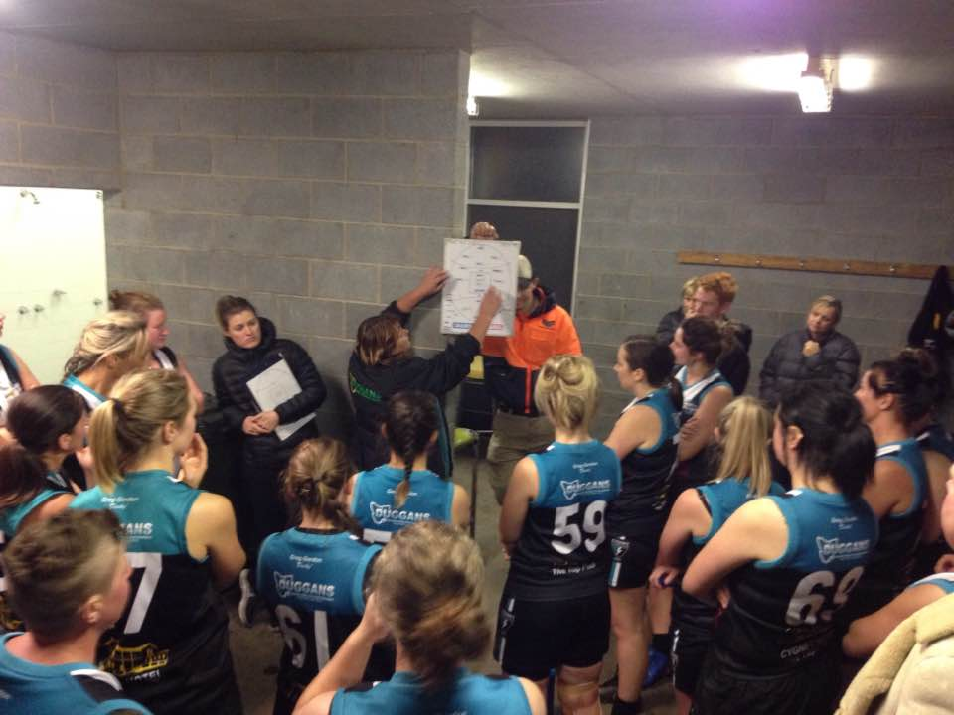
Lindisfarne came out with fresh legs after half time, showing they are a real force in this Competition. Demi Gane continued to apply pressure through the midfield and with an effort to shut down the Two-Blues key players, PORT were able to limit their opponents from running away with a larger win.
Coach Trish talking tactics at half-time

In the Final quarter, PORT continued to fight, never giving up until the final siren. April Pottinger was outstanding on debut in defence and contributed greatly in reducing the final score line. In the end the Lindisfarne Two-Blues ran out victors over the PORT 9.10.64 to 3.0.18. Scotty, Cassidy and Pottinger were outstanding in defence, with Geeves, Phillips and Gane continuing their fine form throughout the game.

Thank you to everyone who came along on such a cold night to support the PORT Women.
This Sunday sees the start of the second round of matches with the PORT taking on the Demons Women at the Kingborough Twin Ovals, with the game scheduled for a 1.40 pm start.

Southern Storm Colts
A big crowd had started to assemble at Kermandie as the Southern Storm ran out to take on the Hobart Tigers who were undefeated after their first five games. With Elijah Reardon and Nathan Duggan back from Senior duties, the Storm were looking to really take it up to the Tigers.
In an evenly contested first half, neither side was able to consolidate an advantage over the other, with the Tigers taking a nine point lead in at half-time. With a three goal to two third quarter the Tigers increased their lead to three goals but the game was still up for grabs.
Unfortunately for the Storm, Hobart started to get their running team game going in the final quarter, kicking four goals to the Storm’s single goal to run out comfortable winners by 38 points. Although not the Storm’s best performance of the season, they did show in patches that they were more than capable of matching it with a top team, but will need to put together a sustained four quarter effort.
Better players for the Storm were Jacob Hayers who continued his recent fine form, George O’Neill, Jack Brereton, Nathan Duggan, Kyle Russell and Peter O’Neill. Jake Dance again hit the scoreboard with three majors, Elijah Reardon kicked two goals, while Jack O’Neill, Luke Ashlin, Liam O’Neill and Scott Blacklow each kicked a goal.

PORT Reserves
With a few of the PORT regular players unavailable, the Reserves welcomed Nick Townsend and Jack Brett for their first games for the Port, along with experienced campaigners Leigh Savage and Grant Clark. As with the earlier Colt’s game, there was nothing much between the PORT and their Tiger opponents early in the game, with only two goals scored by the Tigers in the first quarter.
The PORT got their first goal on the board in the second term but the Tigers countered with three of their own to lead by four goals at half-time. The third quarter was again evenly contested with both teams kicking two goals and the local supporters were hopeful of a PORT comeback in the final quarter. But again, Hobart snuck away with three goals to the PORT’s two, to run out victors by 29 points.
Leigh Savage showed he had lost none of his skills, Aaron Dance was strong in defence, while Brad Sculthorpe, Lucas Pel, Ryan Panton and Chris Stockfeld (3 goals) were other good contributors for the PORT. Other goal scorers were Dwain Warn and Nick Townsend.

PORT Seniors
With the Senior team almost at full strength there would be no excuses in what was considered a potential danger game for the PORT, as the Hobart Tigers were confident coming off a narrow win in their previous game.
The PORT got off to a great start and were soon on the board with three quick goals, but the Tigers hit back with several of their own and the margin at quarter time was only five points in the PORT’s favour. The Halton brothers, Ben and Josh, and Will Ford were proving a handful for the Tiger defence who were under constant pressure. A five goals to two second quarter had the PORT in front by 22 points at the half-time break.

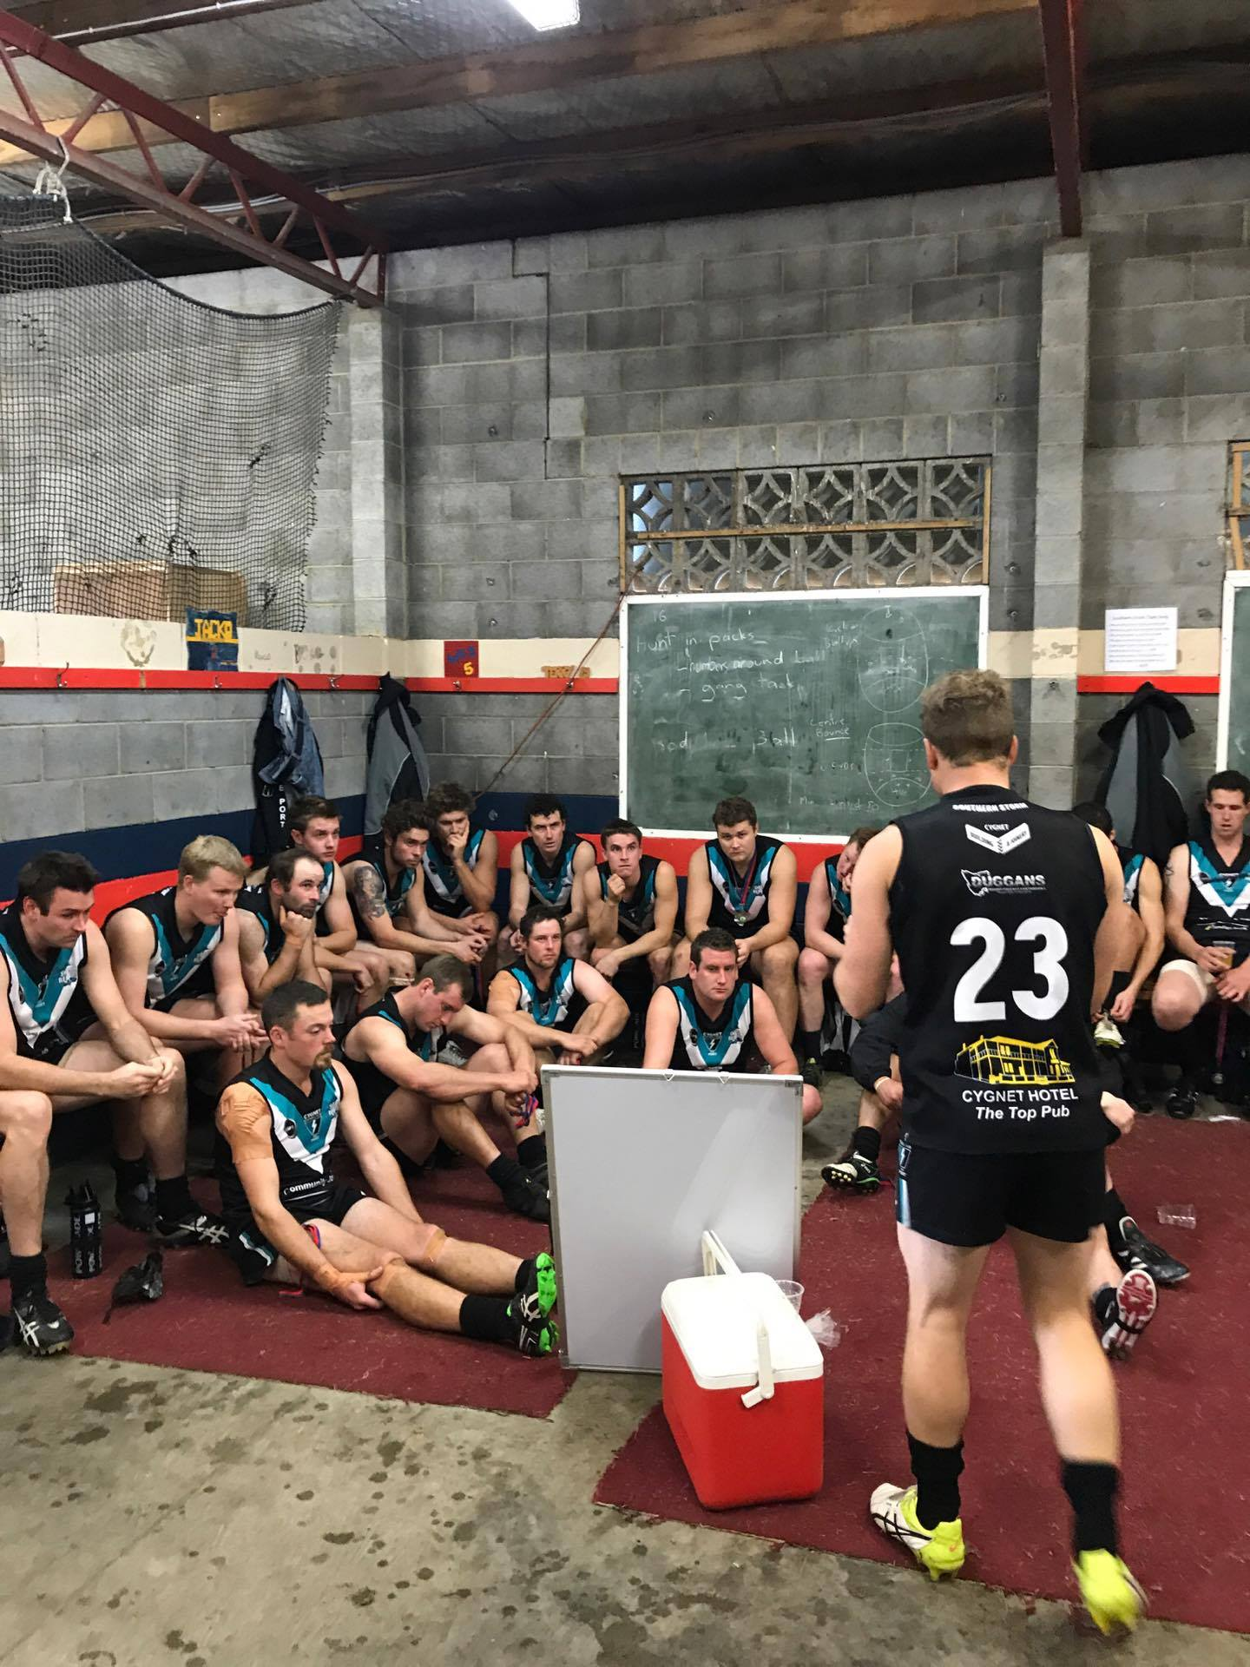
Joe Direen was giving his on-ballers first use and the PORT started getting good run off half-back through Mitch Direen and Corey Polley tackling well and driving the ball long into the forward line, where Ben, Josh and Will continued to hit the scoreboard. Importantly, several other players were also getting in on the goal kicking act. With another five goals for the quarter, the PORT extended their lead to 38 points at the final break and looked in control of the game.
Ben Cato addressing his troops – note medallions around players’ necks to hand to Under 10 boys
The floodgates really opened in the final quarter with the PORT scoring eight goals while Hobart battled bravely with five goals of their own, however the PORT ran out comfortable winners by 57 points.

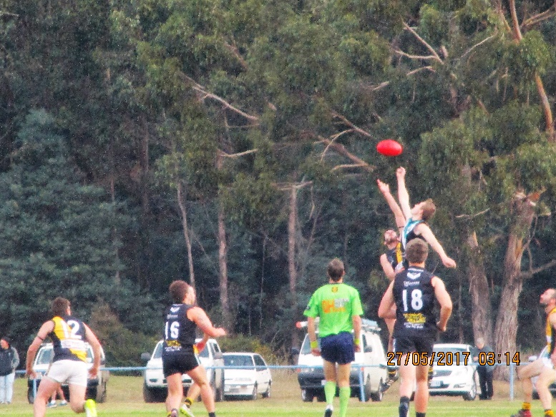
Joe Direen continues to show improvement with his ruck work, while Sam Dean played his typical ‘in and under’ role. Ben Halton snagged a lazy seven goals, Brayden Hayes used his explosive pace to break open the contests, Corey Polley showed the potential he has while Tom Slevin was steady in defence.
Joe Direen wins this ruck contest
Josh Halton and Will Ford each finished with four goals with eight other players also kicking goals.

Under 10s half-time game
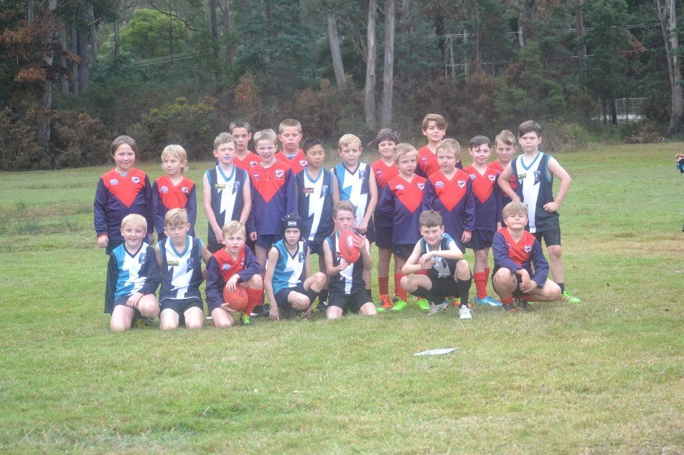
During the Senior game half- time break on Saturday, the Kermandie Storm and Cygnet Storm Under 10 boys played an exhibition match to display their footy skills in front of the large crowd present.
The boys had a great time and after their game they formed a guard of honour outside the Cygnet change rooms.As the PORT Senior players ran out onto the ground for the second half they presented each of the boys with a medal and a high five. A really nice touch.

This Week’s Games
The PORT Senior and Reserve Men’s teams have the bye this round so will not be playing. However, as there is no bye in the Colts competition, the Southern Storm will travel up to Boyer Oval on Saturday to play the New Norfolk Eagles.
The PORT Women will play the Demons Women at the Kingborough Twin Ovals on Sunday (4th), with the game scheduled for a 1.40 pm start.

“Support the PORT in 2017’

