PORT NEWS
GREAT RESULT FOR THE PORT WOMEN
PORT Women
In Round 4 last Sunday, the Port Women hosted the Claremont Magpies at the Kingborough Twin Ovals. Coming off a hard match last week, the ladies went into this week’s game ready to play.

In the opening term, Port got their feet off the ground quickly, with Kara Geeves scoring the first goal of the match. Her consistency for the quarter outstanding, backed up through the midfield from Shez Atkins-Collins and Caitlyn Phillips. With a goal each from Heidi Pettit and Keren Scotney, Port led the quarter time break with a 3.1 to nil lead.

The second quarter mirrored the first with Geeves adding another goal to start things off. Playing her first game in the Women's League, junior Acacia Chapman contributed some great play, with Demi Gane and Atkins-Collins adding one goal each on the scoreboard, taking Port to a comfortable 42 point advantage at the half time break.

In the third quarter, Heidi Pettit cemented her spot up forward, kicking another 2 majors. Geeves continued to dominate play alongside Phillips and with Tash Cormie adding to the team’s goalkickers, Port entered the final break with a significant 67 point lead.

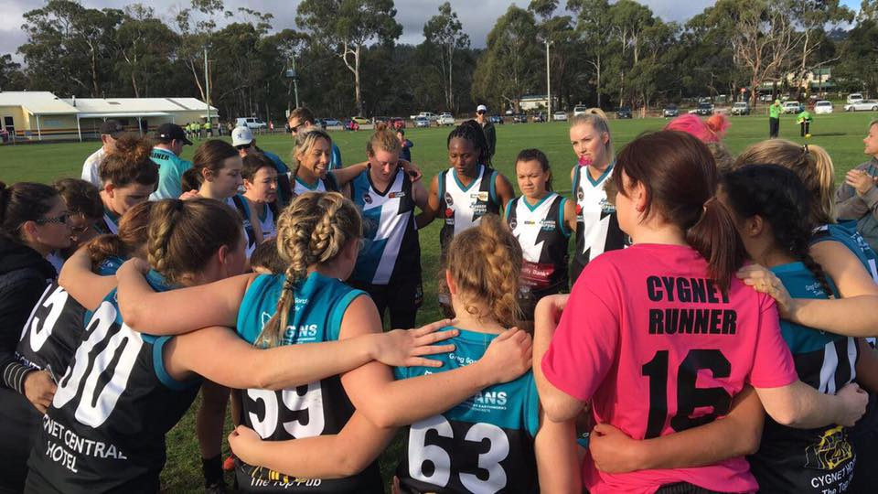
In the last term, Port continued to dominate throughout the midfield and into the forward line, Alice Pace kicked her first match goal for the Port, with Phillips finding enough space to convert another two majors, helping Port to an 86 point victory.

Geeves and Pettit each finished the day with 3 goals, Phillips 2 while Atkins-Collins, Scotney, Gane, Cormie and Pace all contributed singles. Chapman played a great game stepping up, with Geeves, Pettit and Phillips dominating the attacking zone throughout the day. Atkins-Collins and Gane played a solid game through the midfield. A great win for the ladies.

The Club expressed its appreciation to the Kingborough Tigers for their hospitality, the food and for the use of their Trainer, ‘Snowy’ Keating.

PORT/Storm Men

Although there were no SFL roster matches last weekend, several of our Senior and Colt players represented the League in their Representative games against the NWFL at Ulverstone. Unfortunately both SFL teams went down in wet and miserable conditions.

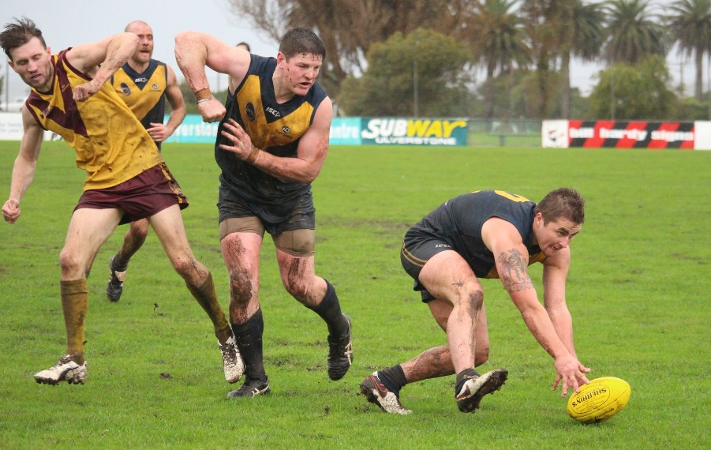
Well done to Ben Cato, Will Ford, Brayden Hayes, Nathan Duggan, Elijah Reardon, Jake Dance, Jackson Gordon and Jack Brereton who flew the flag for the Port.
Brayden Hayes being shepherded by Mick Paul (H'ville)

During the bye round, Port’s Reserve Coaches, Matt Whitehouse and Ollie Burke played for the Kingborough Tigers Mercury Cup side in their 10 point win over North Launceston. The game marked the life membership achievement for their ex-team mate and past Port player, Brad Foster. This was Ollie’s first game after major knee surgery last year and he acquitted himself well kicking four goals.

This week’s Games
This weekend the footy will kick off on Friday night (26th) with the PORT Women playing the Blues Women at Lindisfarne’s ANZAC Park.
On Saturday, football will be back at Kermandie where the PORT and Southern Storm will take on the Hobart Tigers. The Kermandie games acknowledge all the boys from the region who have stuck with the Port and Storm over the years through both good and bad times, and importantly gives them the opportunity to play on their former home ground.

“Support The PORT in 2017”

