HUGE DAY OF FOOTY AT THE PORT
In perfect sunny conditions it was a huge day for the ‘Cygnet Community Bank Football Club’ last Saturday when it played host to archrivals, the Huonville Lions, for the Huon Valley Community Bank Shield. With cars double and triple-parked around the ground, the massive crowd in attendance reminded many of the Huon Football Association battles of the past between these two Clubs.
In addition to the Colts, Reserve and Senior games, the PORT Women’s team played the Hobart Demons in their first game of the SFLW season.
Southern Storm Colts
With four games to be played, the Southern Storm and Huonville Lions Colts had an early start, but it was clear from the outset that the Storm were wide awake and up and running. With the on-ballers winning and getting the ball forward quickly to Marcus Coulson and Elijah Reardon who were running amok up forward, the Storm were quickly on the scoreboard with six first quarter goals whilst restricting their opponents to two behinds. It was more of the same in the second quarter with the Storm kicking four goals to none to open up a comfortable 62 point lead at half-time. The scoring slowed down somewhat in the second half with the Storm kicking six goals to the Lion’s one to run out victors by an even 100 points.
Marcus Coulson had a ‘day out’ kicking 7 goals and getting possessions all around the ground. Will Donato was again very solid down back while others to perform well in an excellent team effort included Jacob Hayers, Jake Dance (2 goals), Riley Surenda-Nicholas and Sean Burgess. Elijah Reardon kicked three goals, with single goals to Matthew Hayers, Jack and Liam O’Neill and Jacab Watson. The Storm now sits in fourth position with two wins and two losses but with the real opportunity to improve their win/loss ratio over the next few weeks.
A very pleasing part of the Storm game was their fast ball movement and ball sharing, with the boys constantly looking for team mates in a better position, particularly around the goals.
PORT Reserves
Without a win this season and with many of the PORT Reserve players never having played in a winning team against Huonville, the challenge was certainly in front of the Cygnet boys to break the drought. Like their Storm team mates, the PORT hit the ground full of run, piling on seven goals in an exciting first quarter while keeping their Lion opponents goalless. The PORT on-ballers were getting first use of the ball but the Lions were not to be outdone and after a fairly even second quarter the margin was 52 points in the PORT’s favour.
A four goals to one third quarter extended the PORT’s lead to a match-winning eleven goals and with both teams kicking three goals each in the final quarter the final margin was 68 points.
Congratulation to Matt Whitehouse and Ollie Burke on their first coaching victory and a long-awaited and morale-boosting win for their team. Paddy O’Neill, Chris Stockfield (3 goals), Matt Cane (3 goals), Adam ‘Rusty’ Direen, Chris Brereton and Matt Turnbull (2 goals) were good contributors in an even team performance. Others to hit the scoreboard were Brad Carver (2), Tim Bakes (2), Lucas Pel, Paddy O’Neill, Tyler Cowen and Ben Smith.
PORT Women
With women from Cygnet, the wider Huon Valley and Kingston keen to pull on the PORT jumper, there was much excitement as they ran onto the ground for their first roster match of the SFLW competition against the Hobart Demons, with Emily Direen as the Captain for the day.
The team was missing one from the bench but was looking to make it a hard contest against the impressive Demons side. They were well supported by the TSLW Kingborough Tigers Women who came down to cheer on their PORT friends and team mates.
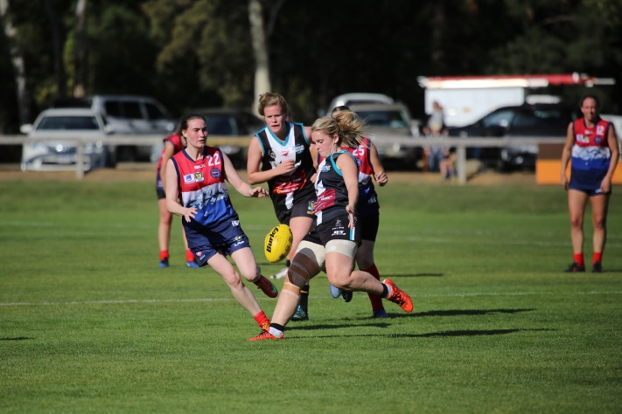
It was a real contest from the word go as players from both teams chased and tackled their opponents. The Demons had slightly the better of the first quarter kicking three goals to the Port’s two to take a narrow 5 point lead into the first break. The second and third quarters were a real arm-wrestle with both team kicking one and two goals in each quarter, and the margin was only 8 points at three quarter time. There was some great tackling done by Caitlyn Phillips, Kara Geeves, Heidi Pettit and Maria Neale.
Caitlyn Phillips gets her kick away
PORT Coach, Tricia Phillips encouraged her team to keep running and continue to put pressure on their Demon opponents. The team settled their nerves, focused and the PORT gradually pulled back the Demon lead and with the crowd heavily involved and cheering on the PORT, drew within two points with about five minutes to play. With a great save on the backline by Jade Harvey, the ball was pushed back up through the centre to be kicked through the tall posts by Heidi in the closing minute of the game. In a most exciting and tense finish the PORT secured the win by 5 points and the celebrations commenced.
In a real team effort, better players for the PORT were Maria Neale (3 goals), Caitlyn Phillips, Gilly Millar, Tara Slater, Emily Direen and Samantha Lind.
Other goal scorers were Tash Cormie, Kara Geeves, Heidi Pettit and Caitlyn Phillips.
All the ladies put in 100 percent effort to make it across the line and sung the PORT song loudly for the first time in the change rooms, and are looking forward to the rest of the season.
PORT Seniors
The PORT Seniors were strengthened by the return of Brayden Hayes, Rhys Synnott, Corey Polley and Patty Verrell in what promised to be another absorbing contest against the Huonville Lions, who had narrowly lost to Claremont the previous week.
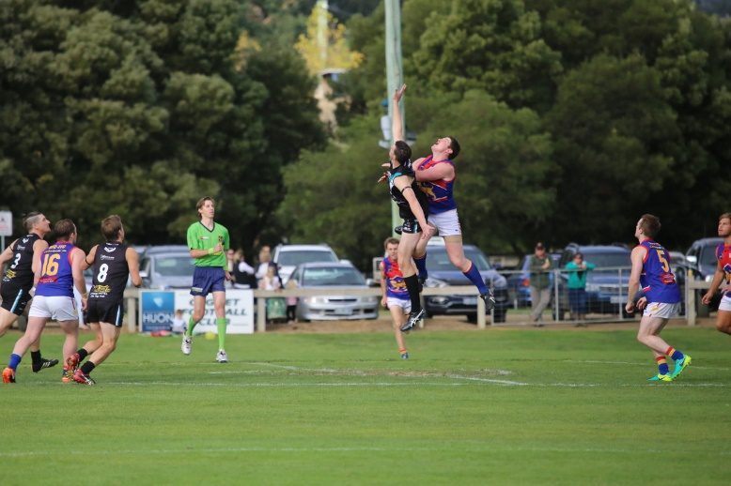
There were no ‘beg pardons’ as both teams hit the contests hard and made their opponents earn every possession. It was an intriguing battle in the ruck between the PORT’s Gerard Brereton and the Lion’s Mick Paul as both tried to give their on-ballers first use of the ball. The PORT got off to a good start with a couple of early goals before the Lions kicked a couple of their own. The margin at quarter time was four points the PORT’s way. The second quarter was more of the same with both teams kicking two goals and neither team able to take the initiative, with the PORT slightly extending their lead to 8 points at half-time as both teams took a well-earned rest.
Gerard Brereton and Mick Paul do battle in the ruck
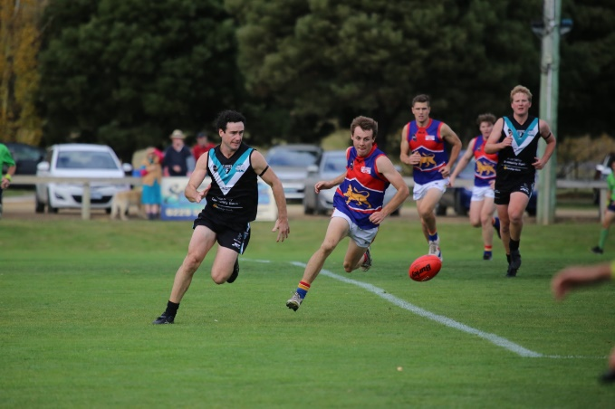
The defences of both teams were under constant pressure in the third quarter as the on-ballers continued to drive the ball forward. The Lion’s Mick Paul was proving a headache for the PORT backs and was almost single-handedly keeping the Lions in the game. However the Lion’s inaccuracy (2 goals 6 behinds for the quarter) against the PORT’s 3 goals meant the PORT retained a nine point lead at three-quarter time.
Mitch Direen contesting the loose ball
In an exciting last quarter, the PORT kicked an early goal before the Lions, with a couple of goals of their own, levelled the scores and the massive crowd were on the edge of their seats. Two superb goals for the quarter to the PORT’s Grant Clark sealed the deal for the PORT with the final margin being 13 points. It was a terrific contest between two teams who never gave an inch to their opponents, and an excellent example of country football being alive and well.
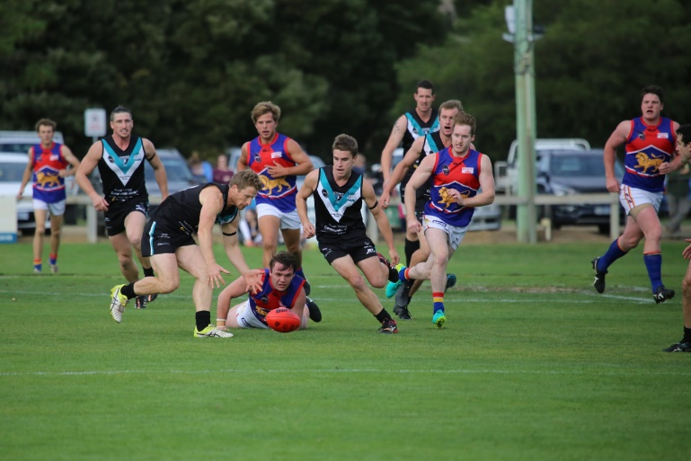
Better players for the PORT were Gerard Brereton, who battled manfully against several opponents in the ruck, Grant Clark, both in defence and when moved up forward where he finished with 2 goals, Ben Halton, who was superb around the ground with his marking and strength in the contests, Will Ford, who marked strongly and created rebound off the backline, Josh Halton, whose strength made him dangerous up forward kicking 4 goals.
Ben Cato gets to the ball with Rhys Jennings close by
Brayden Hayes, who despite an injured arm was always dangerous, particularly up forward, where he also finished with 2 goals.
After such an intense battle it was great to see the Cygnet and Huonville players chatting and sharing a drink in the Clubrooms after the game as local Cygnet Community Bank Manager, Jordan Lovell, presented the Annual Community Bank Shield to the winning PORT Coach, Ben Cato. No doubt the Lions will be seeking revenge over the PORT when the teams do battle again at Huonville in Round 13, so make sure you mark the 15th July in your diary.
Sumo Wrestling Night
To cap off what had been a hugely successful day for the PORT, both on and off the field, the Club’s Social Committee held a hilarious Sumo Wrestling Night after the game. Congratulations to Cam Wilcox and Jess Direen who won their gender events. During the evening the Club and Diddy’s Day Out Committee acknowledged the fantastic efforts of Brayden Hayes and his great support, Jules Direen in their Run for a Cause to Burnie to raise much-needed funds for Motor Neurone Disease and Diddy’s family.
This week’s Games
The PORT Men’s and Storm teams travel to Pontville this week to take on the Brighton Robins who will be extremely keen to get their first wins for the season. The PORT Women have the Bye this weekend.
The following week (13th May) the PORT will again be on the road, this time travelling to Boyer Oval, to play ladder leaders and undefeated New Norfolk. The PORT Women will play the South East Suns at Shark Park, Dodges Ferry on Sunday 14th May.

“Support The PORT in 2017”

