BIG DAY OF FOOTY THIS SATURDAY AT THE PORT
The ‘Cygnet Community Bank Football Club’ this Saturday plays host to archrivals, the Huonville Lions, for the annual Community Bank Shield. The Huon Valley Community Bank is a very generous supporter and sponsor of both clubs.
A big day of football is planned, including the PORT Women’s team playing the Hobart Demons between the Reserves and Senior games. The Southern Storm v Huonville Lions Colts game will start at the earlier time of 9.00am, followed by the Reserves at 10.50am. The Women’s game will commence at 12.45pm followed by the Seniors at 2.15pm. It promises to be a great day of football, so everyone is encouraged to get along to Cygnet and support their local Huon Valley teams.
Last weekend the PORT travelled to ANZAC Park to take on last year’s Minor Premiers, Lindisfarne in what turned out to be very challenging games for all the PORT teams.
Southern Storm Colts
The Southern Storm boys were keen to atone for their narrow loss to Lindisfarne in round one, however Lindisfarne had other ideas and were quickly out of the blocks, establishing a handy three goal lead at quarter time. The early stages of the second quarter went goal for goal but three late goals by the Storm narrowed the margin to just four points at half-time and the game was still up for grabs. Lindisfarne steadied in the third quarter, kicking four goals to the Storm’s one to extend their lead to 22 points and with a further six goals to the Storm’s three in the final quarter, Lindisfarne ran out winners by seven goals.
Better players for the Storm were Liam and Peter O’Neill, Kade Francis, James Zeitzen (2 goals), Jacab Watson and Josh Coad. Will Donato continued his good early season form with two goals, while the other Storm goal scorers were Peter O’Neill, Josh Coad, Jack Brereton, Dylan Gane, Matthew Hayers, Jacab Watson and Jake Dance.
Whilst the result was not what Coach Matt Brereton had hoped for, the performance of several Under 16 boys who filled in was particularly pleasing and a promising sign for the future.
PORT Reserves
The PORT Reserves came up against a tough and fitter opposition and were on the back foot right from the first bounce. With four goals to one in the first quarter, Lindisfarne had opened up a 22 point lead and with a further five goals to one in the second quarter had extended that to almost 9 goals at half-time. With Coaches Matt Whitehouse and Ollie Burke encouraging the PORT boys to man up and play a more contested brand of football, the second half was a much tighter affair with the PORT restricting Lindisfarne to three goals in each quarter. But the scoreboard damage had already been done and Lindisfarne ran out comfortable winners by 85 points.
Shane Clark, Tom Slevin, Chris Brereton, Brad Sculthorpe, Chase Connlley and Daniel Donato were the PORT’s better players, whilst Dwain Warn (2 goals) and Chris Stockfield were the PORT’s sole goal kickers.

PORT Seniors
Two first-gamers, Elijah Reardon and Jeremy O’Neill were welcomed into the senior side, along with Grant Clark, but were without a sore Brayden Hayes.
With the boys starting in a determined manner and Gerard Brereton giving first use of the ball to his mid-fielders Sam Dean, Ben Halton and Andrew Palmer, the PORT got off to an excellent start and had three goals on the board before Lindisfarne had scored.
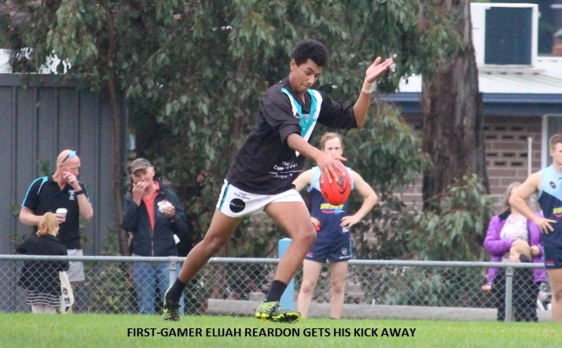
An early highlight was the great goal by youngster Elijah ‘Cyril’ Reardon which showcased his fine footballing skills.
Will Ford and Cam Wilcox were excellent in defence, repelling many of Lindisfarne’s early attacks. However Lindisfarne slowly drew level with the PORT and with four goals late in the quarter led the PORT by three goals at quarter time. The second quarter was an even affair with the PORT winning the early part of the quarter and getting themselves back into the game to narrowly regain the lead. But once again, four late goals by Lindisfarne had them up by that margin at half-time.
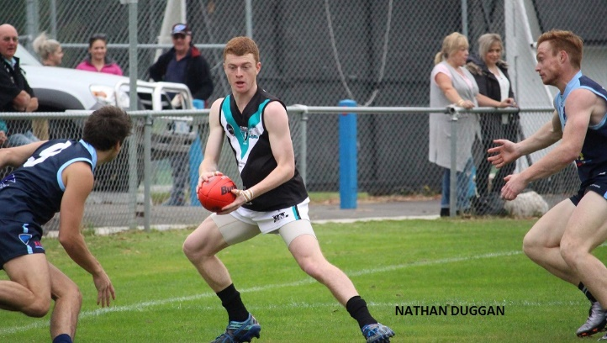
The all-important third quarter was a real arm wrestle with the PORT slightly outscoring Lindisfarne and at three quarter time the margin was 20 points with the PORT still very much in the game. However a six goals to one final quarter by the home team extended their lead to 52 points at the final siren. Like the previous week against Claremont, the PORT had really taken the game up to their opponents, but lapses, often late in quarters, let Lindisfarne establish a game winning break, which in the end was just too difficult to bridge.
Ben Halton was inspirational all day, whether on the ball, across half back or up forward, finishing with four goals. Sam Dean continued his fine form from the previous week, Rhys Jennings was in and under the packs, Cam Wilcox battled hard all day on ex-Lauderdale player, Michael Cassidy, while Nathan Duggan and Josh Halton also acquitted themselves well.
Joe Direen and Josh Halton each booted three goals, with single goals to ‘Cyril’, Matt Whitehouse and Jackson Gordon.
Sumo Wrestling this Saturday Night
The Club is holding a Sumo Wrestling Night after this week’s games, so stay around for what promises to be a great night of fun. The night will also thank Brayden Hayes and Jules Direen for their Run for a Cause to Burnie to raise funds for Motor Neurone Disease and Diddy’s Day Out. Mark ‘DJ’ Direen will also be plying his trade from 9pm.
“Support The PORT in 2017”

