NEWS FROM THE PORT
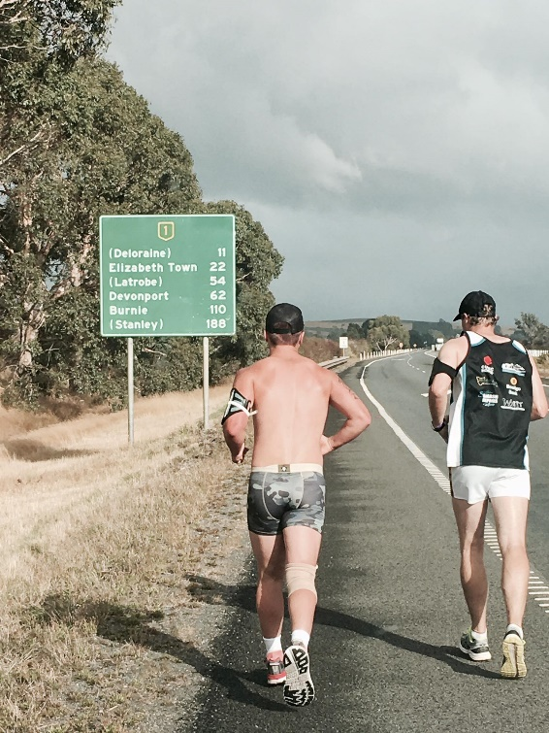
Congratulations Brayden Hayes and ‘Run for a Cause’
After 11 days and 325 kms on the road, PORT Assistant Coach Brayden Hayes arrived in Burnie to complete his marathon run, which raised much-needed funds for Motor Neurone Disease (MND) Research and Diddy’s Day Out. The run followed a bold statement from Brayden that if the Hobart Hurricanes beat the Renegades in the Big Bash Cricket, he would run from Hobart to Burnie in his undies for charity.
The Cygnet Football Club is extremely proud of Brayden’s effort and that of Club legend, Jules Direen, who ran beside Hayesy for 9 of the 11 days.
‘Run for a Cause’ raised well over $20,000, a magnificent effort. Congratulations Hayesy and your support team.

Disappointing Day for the PORT
The PORT journeyed to Dodges Ferry last Saturday to take on the Sharks in the first roster game of the 2017 season, but unfortunately the day’s results were not what the Club was hoping for.
Southern Storm Colts
A late change to the SFL Roster meant that the Southern Storm Colts played Lindisfarne Colts prior to the Reserve game. Although only having 18 available players, the Storm got off to a flying start and at one stage lead by over 40 points before Lindisfarne started working their way into the game. The Two-Blues, with superior fitness, gradually whittled away at the Storm’s lead and in an exciting finish to the game, Lindisfarne snatched the lead with two minutes to go in the final quarter and held on to win by three points. Coach Matt Brereton believes there is a lot of improvement left in the team but this will require the Storm lads to put in the hard work necessary to attain the level of fitness required to perform against the top level teams in the competition and again be a real premiership contender.
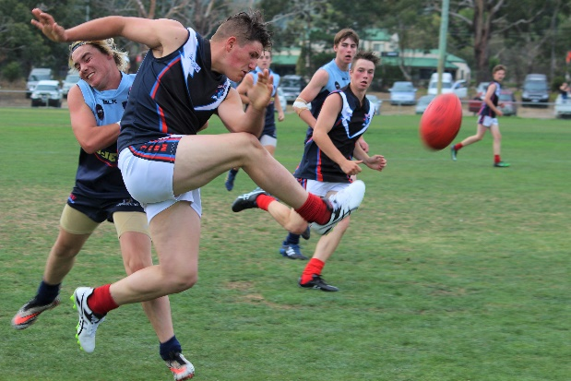
Last year’s Best and Fairest winner, Nathan Duggan, continued where he left off last season, putting in a very solid performance, while other good players for the Storm were Jake Dance (2 goals), Kyle Russell, Jack Brereton, Jacob Watson and Will Donato (2 goals). Liam O’Neill also kicked two goals, with Nathan Duggan, Jack O’Neill and first-gamer Jacob Hayers each scoring a goal.

PORT Reserves
The PORT Reserves, led by co-coaches Matt Whitehouse and Ollie Burke were keen to start the season on a positive note. After an even first quarter the Sharks held a narrow five point and the second quarter went goal for goal as Dodges increased their lead to two goals at half-time. Again lack of fitness proved to be a killer for the PORT as the Sharks started winning the stoppages and moving the ball quickly to their forwards, creating numerous one on one contests for their forwards. With the breeze picking up late in the game, both sides were inaccurate but Dodges were able to kick five goals to one in the final quarter to run out comfortable winners by 50 points.
Experienced players Tom Slevin and Matt Cane battled hard all day and were well-supported by first-gamers Julian Parker, Adam ‘Rusty’ Direen, James Booth and Chase Connelly. Chris Stockfield and Matt Cane both kicked 2 goals with Brad Carver scoring one goal.
PORT Seniors
New Senior Coach Ben Cato, who returned to The PORT after a distinguished career with Clarence and Richmond (Old Scholars Football Association) was joined by ex-players Andrew Palmer, Tom Nichols, Rhys Synnott and key forward Josh Halton in the Senior side. The PORT hit the ground running and were winning most of the centre clearances and giving their key forwards Ben and Josh Halton plenty of opportunities. Half way through the quarter The PORT had established a handy six goal margin before two late goals by Dodges reduced the quarter time margin to four goals. Game-ending injuries to Rhys Synnott (knee) and Tom Nichols (hamstring) in the second quarter blunted some of The Port’s on-ball dominance and by half-time the Sharks had got their running game going and lead by eight points.
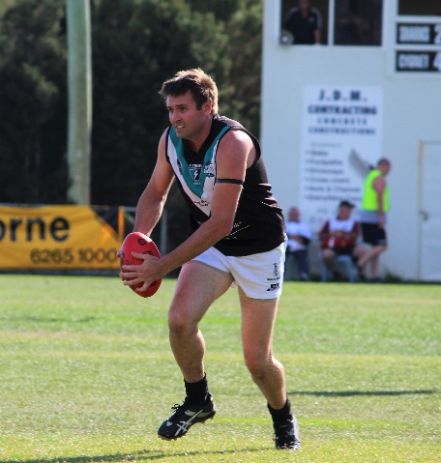
The third quarter was an even affair and despite drawing level, two late goals by Dodges increased their margin to 13 points at the final break, but looking in control of the game. Unfortunately further injuries to Paddy Verrell and Corey Polley during the quarter meant that The PORT had run out of interchange options. This proved telling in the final quarter and with several other players struggling with niggles, the Shark’s superior fitness and ball movement allowed them to pile on five goals to one for a final margin of 47 points.
Better players for The PORT in a disappointing result were Cam Wilcox who battled manfully down back and snuck up forward to kick two goals, Andrew ‘Cheesy’ Palmer, Ben Halton both up forward and on the ball, Will Ford and youngsters Jackson Gordon and Joe Direen.
The main goal scorers were Josh and Ben Halton, each with 3 goals, Tom Nichols (2), Cam Wilcox (2) and Brayden Hayes (2).

Next week’s games
The challenge this Easter Saturday is for all three teams to quickly regroup and prepare to take on last year’s Premiers in all three grades, Claremont, in the PORT’s first game. This week will also see Loic Auderset play his 100th game for the Club. A great achievement, well done Loic.
The following week The PORT will travel to ANZAC Park to take on last-year’s runners-up, Lindisfarne. Certainly a tough draw to start the season, but a great opportunity to see where The PORT sits in relation to the top teams.
SFL Womens Update
On Sunday the PORT ladies travelled to Abbotsfield Park, Claremont for the SFLW Gala Day. The weather was not kind with the ground wet and slippery, making marking and ball handling interesting. With only 16 players available and no interchange, the PORT ladies had to play both games with no relief, bar swapping positions on the field.
After the toss by Captain Emily Direen, the first game got underway against the experienced South East Suns team. The ladies fought hard in the centre and backline to keep the scoring low but found it very difficult getting the ball up forward to score. The ladies kept their composure after the change to fight the game right out and were rewarded a few times by the umpires with the ball being handed the PORT’s way. The team came off and discussed the game and rehydrated before warm ups commenced again for the next game against the Demons.
The Demons got off to a fast start kicking a goal but under the PORT’s backline pressure could only manage a few points before the half-time break. The tanks were starting to drain after one and a half games but after a few changes the PORT played a great second half kicking a couple of goals and points while pressure from the centres and backline kept the Demons scoreless in the last half. Despite an injury which left the PORT with only 15 players, they managed to hold on for a well-deserved win.
The team should be very proud of their efforts and thanks go to David, Cynthia, Tom and friend for organising, training and being water carriers on the day. Thanks also to the Kingborough Tigers ladies who came along to support both on and off the field. They provided great direction, team spirit and values to stick with. The PORT ladies look forward to continue working with the Tiger ladies throughout the season.
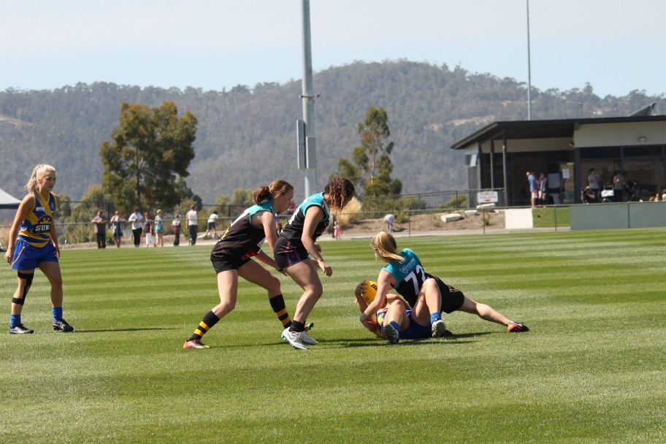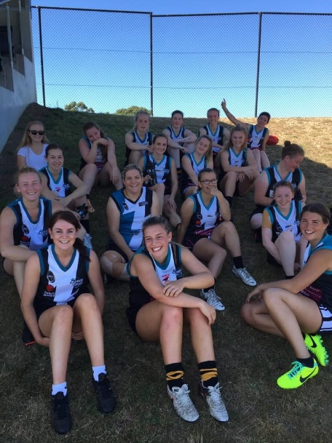

“Support The PORT in 2017”

