DISAPPOINTING DAY FOR THE PORT
The ‘Cygnet Community Bank Football Club’ travelled to Sorell’s Pembroke Park last Saturday hoping to come away with a victory which would cement the Senior’s position in the final five, and also keep the Reserve’s final chances alive. However, in perfect playing conditions, it was not to be, as Sorell scored victories in both games.
Although the Southern Storm Colts had the bye, it was great to see many of the Colts willingly put their hand up for selection if required, an offer taken up by both the Reserve and Senior teams.
The Reserves, keen to celebrate Tommy Slevin’s 150th Club game with a win, started the game slowly and were having trouble with Sorell’s slick ball movement in the first half, finding scoring opportunities hard to come by. Sorell held a handy six goal lead at half-time and with Coach ‘Stick’s Clark urging his players to attack the ball and look for each other, the third quarter was a much better effort by Cygnet as they gradually worked their way back into the game, reducing the deficit to 28 points at the last break. Unfortunately the Port could not sustain this effort in the last quarter with Sorell scoring three goals to two to run out winners by 37 points.
Jack Bester continued his excellent form from the Colts and won many possessions, Chris Brereton and Paddy Ford both battled hard in the ruck and around the ground, while Jarryd Atkins and Paddy Wilcox were hard at the contests all day. Jamie Direen made his presence felt while the goals were shared between Jake Dance, Jack Bester, Campbell Gane, Shane Clark and Jamie Direen.
The win leaves Cygnet Reserves a game and percentage outside the top five with two games remaining against Huonville and Hobart who are placed 4th and 5th on the ladder respectively.
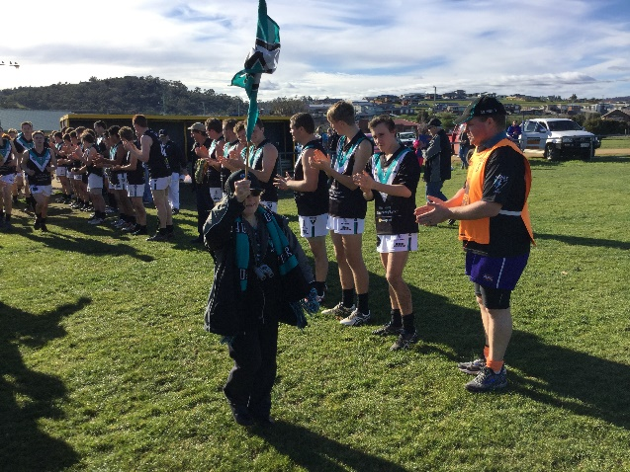
The Club’s No. 1 supporter, Therese Donohoe, celebrating her 50th birthday, led the Seniors onto the ground through a guard of honour of both Cygnet and Sorell players and tossed the coin before the start of the game.
The Seniors welcomed back Jason Laycock but were without Gerard Brereton and Bradley Watson due to injury, while ‘Pud’ Darcy and Mitch Direen was both unavailable. The first quarter was a tight and free-flowing affair with both teams getting plenty of the ball and creating scoring opportunities. Unfortunately the Port’s inaccuracy cost them dearly as they missed several set shots whilst Sorell were much more accurate and held a six point lead at quarter time. The second quarter was a very tight and even affair but several 50 metre penalties late in the quarter ‘gifted’ goals to Sorell, allowing them to maintain a narrow four point lead at half-time.
The third quarter continued to be a tight contest with both backlines under constant pressure. It was now Sorell who were inaccurate in front of goals, with the Port’s defence keeping them to eight behinds for the quarter, while the Port managed to kick one goal four behinds. The margin was now only two points at three quarter time and another exciting finish was on the cards. The Port kicked the first goal of the final quarter to take the lead but Sorell immediately replied to regain the lead and then another to the Eagles opened up a six point lead before a Cygnet goal tied the scores half way through the quarter. It was goal for goal as the lead again changed and with only a couple of minutes to go the Port led by 5 points. With their final forward thrust Sorell was able to capitalise and score the final goal of the match just before the siren went, giving them victory by the narrowest of margins, one point!
Sam Dean continues to get better each game and was again superb around the packs, winning many of the hard balls, Jacob Brereton excelled in the ruck duels and marked strongly around the ground. Rhys Jennings and Colts Jackson Gordon (two goals) and Liam O’Neill never gave up trying, winning many contests and Will Ford was again strong in defence and gave good run off the backline.
Jason Laycock was the major goal scorer with three goals, Jackson Gordon and Gav Quirk each kicked two goals with singles kicked by ‘Twiggy’ Ross, Rhys Jennings, Ben Halton and Brayden Hayes.
Cygnet certainly had their chances to win the game and consolidate their ladder position and lock in a home final. Unfortunately it was not to be and this week’s game against Huonville at Kermandie will be critical in deciding who gets a home final come the first week in September.
BIG LOCAL DERBY AT KERMANDIE THIS SATURDAY
Make sure you get along to Kermandie this Saturday in what promises to be three great contests against Huonville, with final’s positions up for grabs. Go The Port!
RED FACES NIGHT (20th August)
Don't forget about Red Faces coming up on Saturday 20 August - our last home game for the 2016 season! Everyone loves red faces night, it is always a great time filled with friendly banter and laughs all round!! So starting getting your ‘act’ together.

Major Sponsor: Cygnet ‘’Top’’ Hotel
Naming Rights Sponsor: The Huon Valley Community Bendigo Bank
Associate Sponsors: Tascon, Duggans Pty Ltd, Southern Smash Repairs, Abel Labels, Cowen’s Drapery, Cygnet Water Cartage, Cygnet Newsagency, Cygnet Building and Joinery, Farah’s IGA Everyday, Elite Painters, B&T Glass, Robert Armstrong MLC, Mal’s Hire & Hardware, Luke Synnott Excavations and Contracting, Aaron Gordon
Weekly Award Donors: Phillip & Loretta Wilcox [Wilcox Electrical], Bill Cribbin’s BP Cygnet, Roys Bits of Old Pizza and R & D Meats
‘’Support the Port in 2016’’

