PORT TO HONOUR 1976 PREMIERSHIP SIDE THIS SATURDAY
It will be a huge day at Cygnet Oval this Saturday when the Cygnet Football Club hosts its annual Past Players & Officials Function. With former Hawthorn and Gold Coast hard man, Campbell Brown as guest speaker, the day will be also be the 40th year celebration of the 1976 Senior Premiership team that was coached by local footballing identity, and Cygnet Football Club champion full-back, Brian ‘Gormo’ Dillon.
‘Gormo’ said that the whole Club had a good year in 1976, with the Seniors finishing second on the ladder to Channel. A highlight of the season was Cygnet’s champion full-forward, Greg ‘Welshman’ Howard kicking 22 goals against Franklin in the last roster game. This broke the HFA record of 18 goals set only a few weeks earlier by Huonville’s Lee Paul.
In the Second Semi-Final, Cygnet were soundly beaten by Channel by 80 points, with Channel’s Ashton Denehey unbeatable at full forward, kicking 13 goals. ‘Gormo’ remembers moving himself off Denehey after he had kicked 8 goals, but he continued to trouble the other Cygnet backs.
Cygnet then had to regroup and faced Kermandie in the Preliminary Final. After a close hard-fought battle all day, Kermandie led by four points late in the game when Trevor Direen somehow got the ball through a wall of four Kermandie players to Lenny Holland, who snapped an impossible goal from the boundary line to give the Port a two point victory and another shot at Channel in the Grand Final.
In a great achievement for the Club, Cygnet had all three sides playing on Grand Final day. Unfortunately the Under 17’s were narrowly defeated by Channel by two points and Kingston were too strong for Cygnet’s Reserves, winning by 12 goals. Keen to get one victory out of the day, the Senior game was a close struggle until the Cygnet boys got a bit of a break on Channel in the third quarter to lead by 13 points at three-quarter time. They extended their lead in the last quarter but Channel came home with the proverbial ‘wet sail’, kicking the last four goals of the game, but it was too late as Cygnet held on to win by five points, and become 1976 HFA Premiers.
‘Gormo’ recalls someone saying that if the game had gone for another minute Channel would have won. His reply, in typical ‘Gormo’ style, was “if the siren had gone 5 minutes earlier, Cygnet would have won by 28 points!”
No doubt, these and many more tales of former glory and achievements will be told and retold at the Past Players & Supporters function on Saturday.
The celebration of the 1976 Premiership team head-lines what is going to be a huge day for the Club this Saturday, both on and off-field at the Cygnet Oval. The Port will be hosting the Sorell Football Club in what are must win games to keep the Club’s finals hopes alive. Traditionally, the Port teams seem to lift in knowing so many former great, talented, and hard at it Cygnet players are watching on during the day.

The 1976 Senior Premiership Team is pictured below:
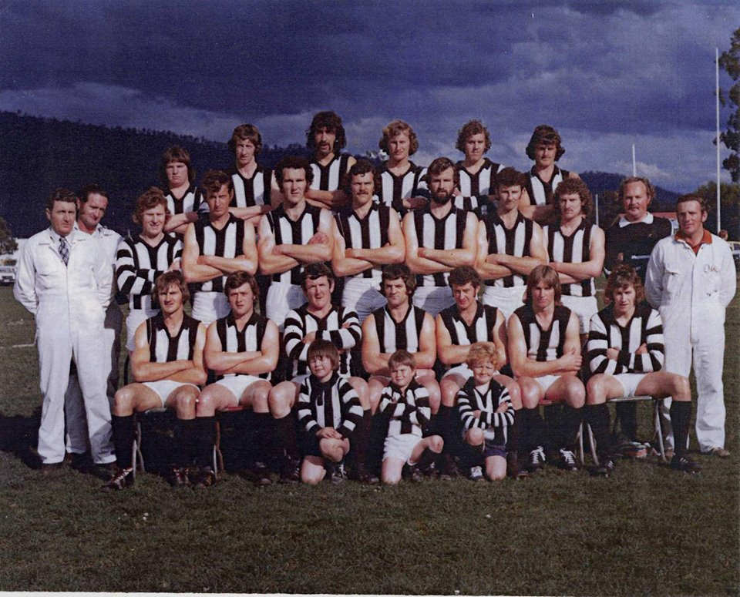
Back Row: Maurice Jarrett, Allan Cockerill, Roger Townsend, Les Craig, Garry ‘Pop’ Rogers, Ricky Bourke
Middle: Kevin Poole, Raymond Howard (Trainers) Leon ‘Bluey’ Barrett, Rodney Direen, Greg Howard, John Hill (dec), Vincent Oakford, Tom Elwell, Mark Synnott, Peter Rafferty (dec) Team Manager
Front: Johnny Clifford, Colin Cowen, Brian Dillon (Captain-Coach), Trevor Direen (Vice-Captain), Stanley ‘Tidsy’ Smith, Lenny Holland, Greg ‘’Ducky’’ Gordon (dec), Graeme ‘’Oigle’’ Bone (Trainer)
Mascots: Glen ‘Dugsy’ Clark, Rodney Dance, Mark Dance
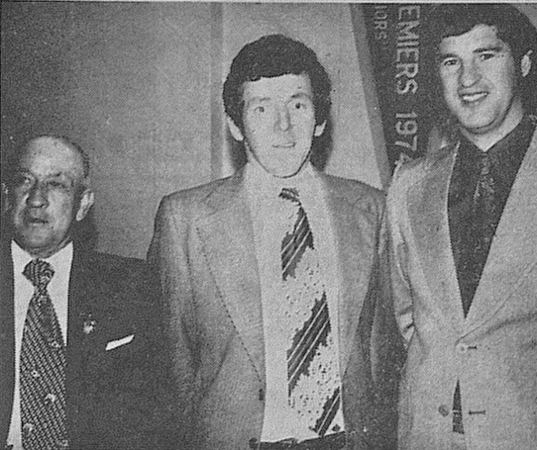
Pictured above at the Club’s 1976 Premiership Ball, (from left) Jim Coad, Club President, Brian ‘Gormo’ Dillon, Premiership Captain-Coach and the great Peter Hudson, who was Glenorchy FC Coach at the time.

