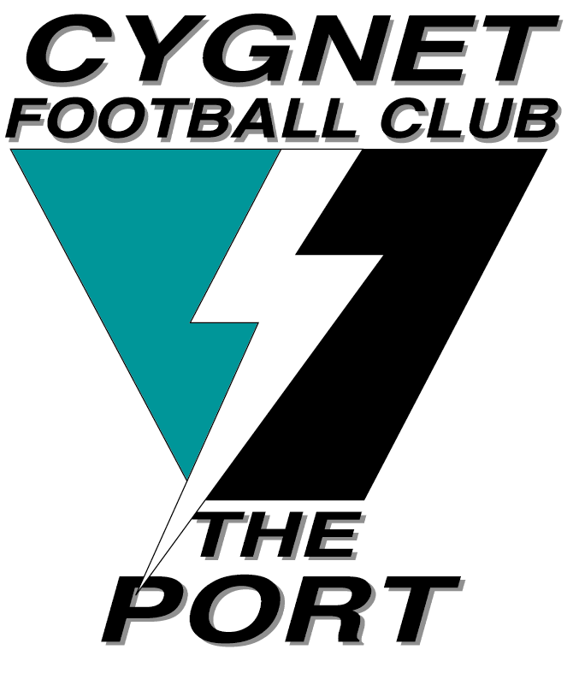

A GREAT START TO SEASON 2016 FOR ‘THE PORT’
For the first time in many years, the Cygnet Community Bank Football Club was victorious in all three games against the New Norfolk Eagles last Saturday.
We all know that one successful round of football certainly does not mean a premiership, but after being on the receiving end of 40 goal drubbings in recent years, it does show that the club is on the right track to rebuilding its pride and winning ways. This week’s game against 2015 SFL Premiers, Claremont at Abbotsfield Park will definitely be a tough challenge and the Port will need to continually lift its performances if we are to be really competitive against the strong SFL Clubs.
Coach Matt Brereton had his Under 18 Cygnet Southern Storm boys primed and ready to play and they got off to a great start, kicking four goals to none in the first quarter. The on-ballers were getting their share of the ball, with Paddy O’Neill and Joe Direen providing great targets up forward. Although the strong wind was playing havoc with both teams’ accuracy on goal, the Storm boys through great team work and slick ball movement were able to extend their lead at every change, eventually running out comfortable winners by 50 points. Better players in an excellent team effort were Nathan Duggan, Peter O’Neill , Jack Bester, Jackson Gordon, with Paddy O’Neill and Joe Direen each kicking four goals and Elijah Reardon chipping in with two valuable goals.
The Storm’s success laid a great platform for the Reserves game, with Sticks and his men similarly getting off to a flying start with the strong wind to the bottom goals, kicking 4 goals to nil in the first quarter. The Eagles had the better of the second quarter and used the wind well to go in at half time only 7 points down. The third quarter was an even affair with both teams kicking three goals, with Cygnet looking to have the job in front of them in the final quarter as New Norfolk again the strong wind at their back.
However, The Port defence was able to keep their opponents scoreless whilst kicking two goals of their own against the wind, including a great after-the-siren shot from Damo Duggan, to record a 21 point win. The boys sung the Club song with much gusto, with the new boys Darcy Millhouse and Chris Coventry (both ex-Channel), Tim Bakes and Matt Coulson celebrating the win in the centre of the circle. Better players, again in a great team effort, were Tom Slevin, Darcy Millhouse, Brendan Dare (2 goals), Ian Coulson, Tim Bakes and Reece Polley.
The pressure was then on the Seniors to make it a hat trick of wins, but a proud New Norfolk, who hadn’t lost to The Port in over ten years, had other ideas. Kicking with the strong wind, Cygnet kicked the only two goals of the first quarter, but were also inaccurate kicking seven behinds to lead by 14 points at the first break. ‘Big Bird’ Brereton was giving first use of the ball to his on-ballers and new recruit Jason Laycock (two goals) was marking strongly and providing a focal point up forward.
As expected, New Norfolk got their game going in the second quarter kicking two goals to one, reducing the margin to 10 points at half time. The third quarter was an even affair with both teams kicking three goals but again inaccuracy and some missed chances didn’t help The Port’s cause. With Laycock off the ground with an injured foot, what promised to be an exciting last quarter certainly delivered as the Eagles scored two quick goals with the breeze to move within a kick of the lead. However steadying play and late goals to Ben Halton and Grant Clark relieved the pressure, sealing a well-deserved 15 point victory to Cygnet.
In a fantastic team effort, Ben Halton played the General role across half back in a best on ground performance. He had great support from ‘Noodles’ Clark, Jacob and Gerard Brereton, ‘Pud’ Darcy and Matty Dance, whilst Coach Gavin Quirk (two goals) and Brayden Hayes knocked up getting kicks.
The Club’s first social function, with the internationally-renowned ‘Matt Hale Comedy Hypnosis Show’, was a great success and a really funny night. Thanks to our Social Committee who did a fantastic job in organising the event, to all those who attended and to ‘DJ Direen’ for providing the music late into the night.
NEW CHANGE ROOMS – OFFICIAL OPENING
The official opening of the Club’s new change rooms will now be held at our home game against Dodges Ferry on Saturday 30 April, at 1.15pm. Come along on the 30th and check out the new facilities on what promises to be a great day of footy.
WANT TO BECOME A MEMBER?
The Club has several membership packages available, ranging from $65 which includes a Club cap and a free drink or food to the value of $5 at each home game. Player sponsorships are also available for $120. Check out our Port Cygnet Football Club Facebook page for more details or please see Marcus Synnott and get on board The Port train in 2016.
PAST PLAYERS AND SUPPORTERS DAY – SATURDAY 28th MAY
Put this date in your diary, as it again promises to be a great day. Further details will be provided shortly on our guest speaker, cost etc.

Major Sponsor: Cygnet ‘’Top’’ Hotel
Naming Rights Sponsor: The Huon Valley Community Bendigo Bank
Associate Sponsors: Tascon, Duggans Pty Ltd, Southern Smash Repairs, Abel Labels, Cowen’s Drapery, Cygnet Water Cartage, Cygnet Newsagency, Cygnet Building and Joinery, Farah’s IGA Everyday, Elite Painters, B&T Glass, Robert Armstrong MLC, Mal’s Hire & Hardware, Luke Synnott Excavations and Contracting, Aaron Gordon
Weekly Award Donors: Phillip & Loretta Wilcox [Wilcox Electrical], Bill Cribbin’s BP Cygnet, Roys Bits of Old Pizza and R & D Meats
‘’Support the Port in 2016’’

